1. Install

* Drag the cross-browser.xpi to firefox window
* Click the popup window’s “Install Now” button

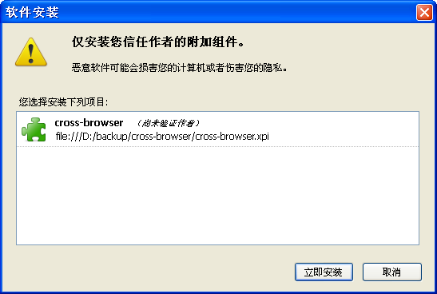

* Restart the firefox

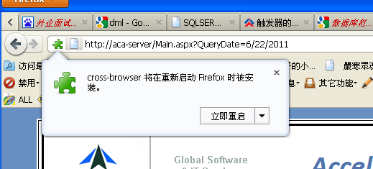

* After install successful, selected the menu-> view -> toolbars -> cross-browser

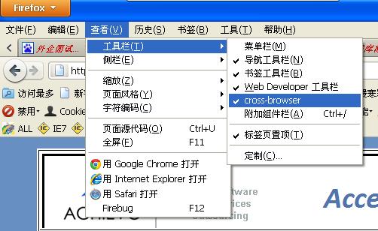

* the toolbar will display in the firefox



1. Using

* Create the virtual directory in IIS.( Different from the red part of each machine, select a directory based on the actual situation)

Using this directory C:\Documents and Settings\

<login user name>

\Application Data\Mozilla\Firefox\Profiles\<b7ky7xna.default>\FulinToolbarData

About <b7ky7xna.default> directory:

Input the “about:support” in firefox address field, click the “open containing folder” button. if “FulinToolbarData” folder does not exist, create it!

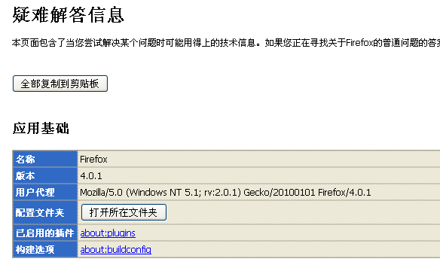

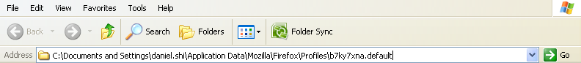

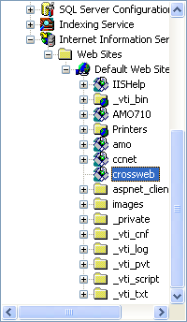

* Click options button in firefox toolbar to setting the local service, with you in the above steps to create a consistent link, click ok button to save it.

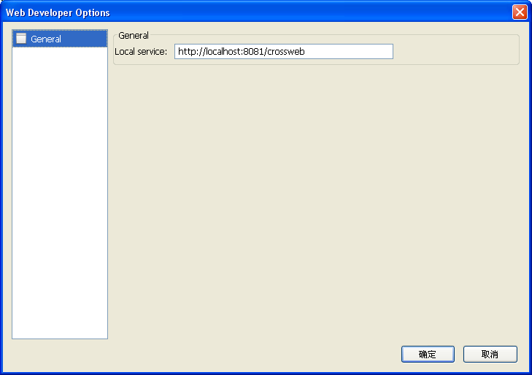

* Now , it is ok!

1. Package

* As shown, select those files into a zip package. Rename the generated files into. Xpi

